1. 新建项目，练习教材上相关例子Hello.java文件，P29。并练习如何在Tomcat服务器上发布该文件

1） HelloServlet文件内容

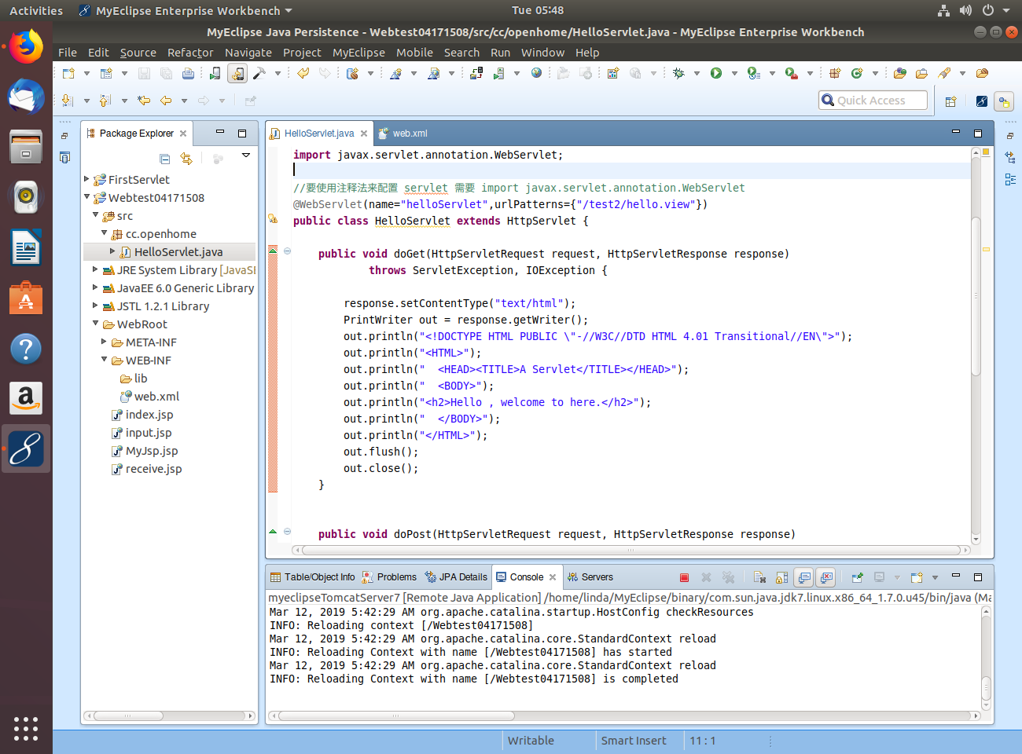

2）注释法（上述代码有注释法）

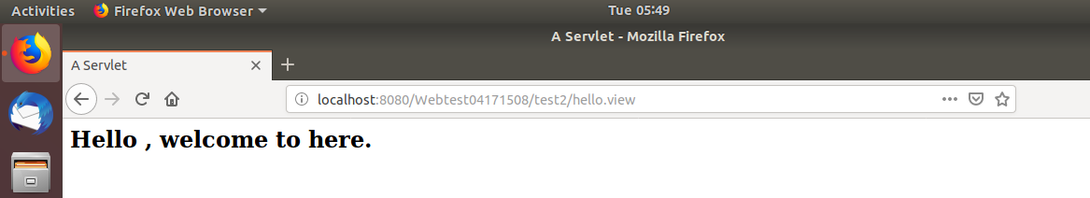

文件配置法

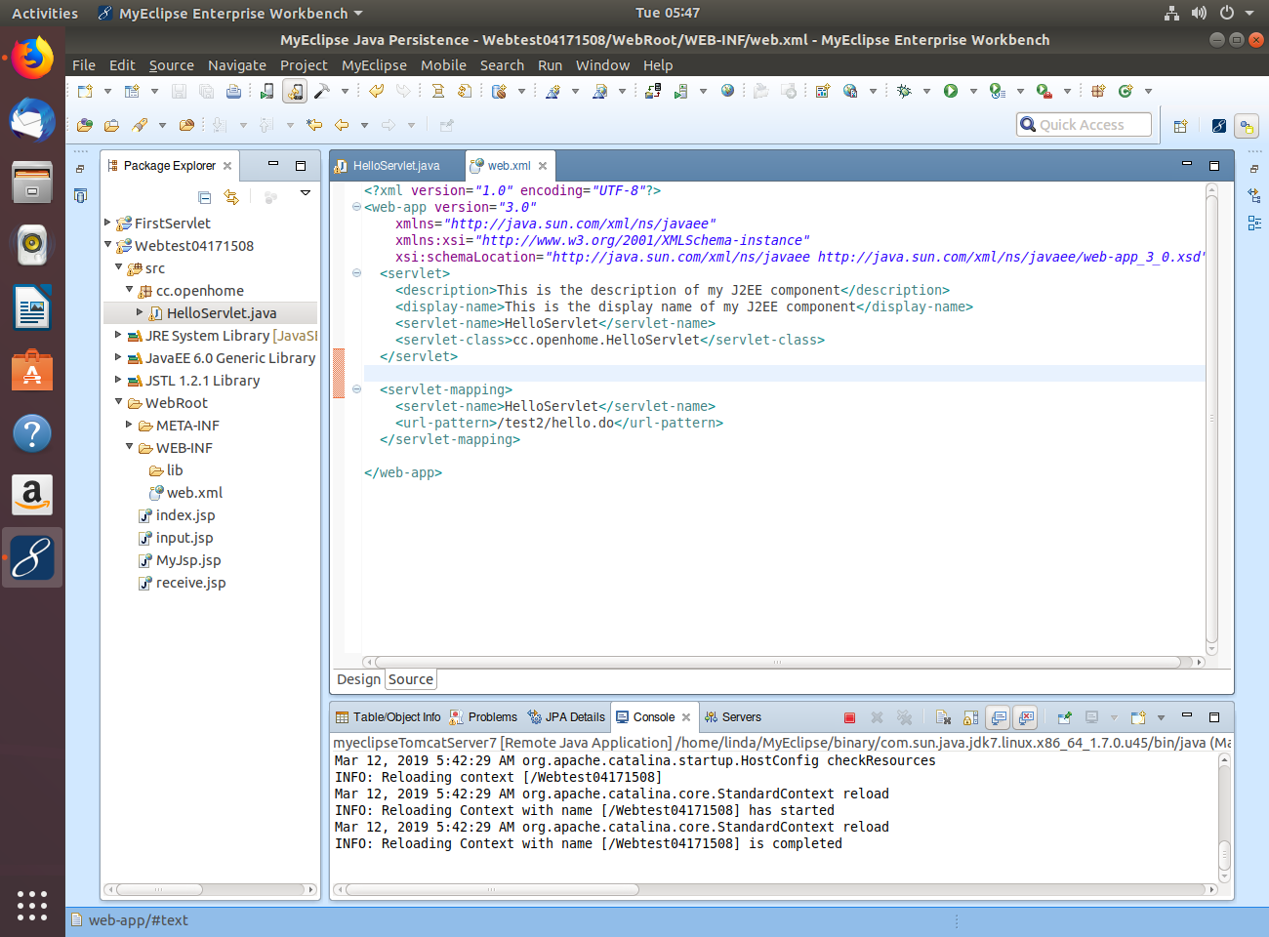

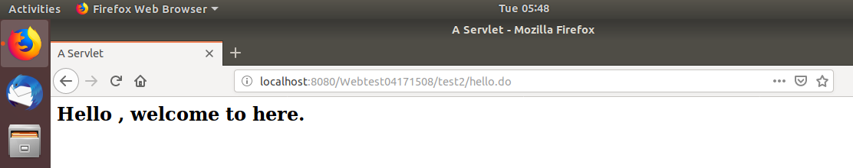

2. 编写WelcomeYou.java文件（需要添加第18行才不会发生传中文乱码的情况）

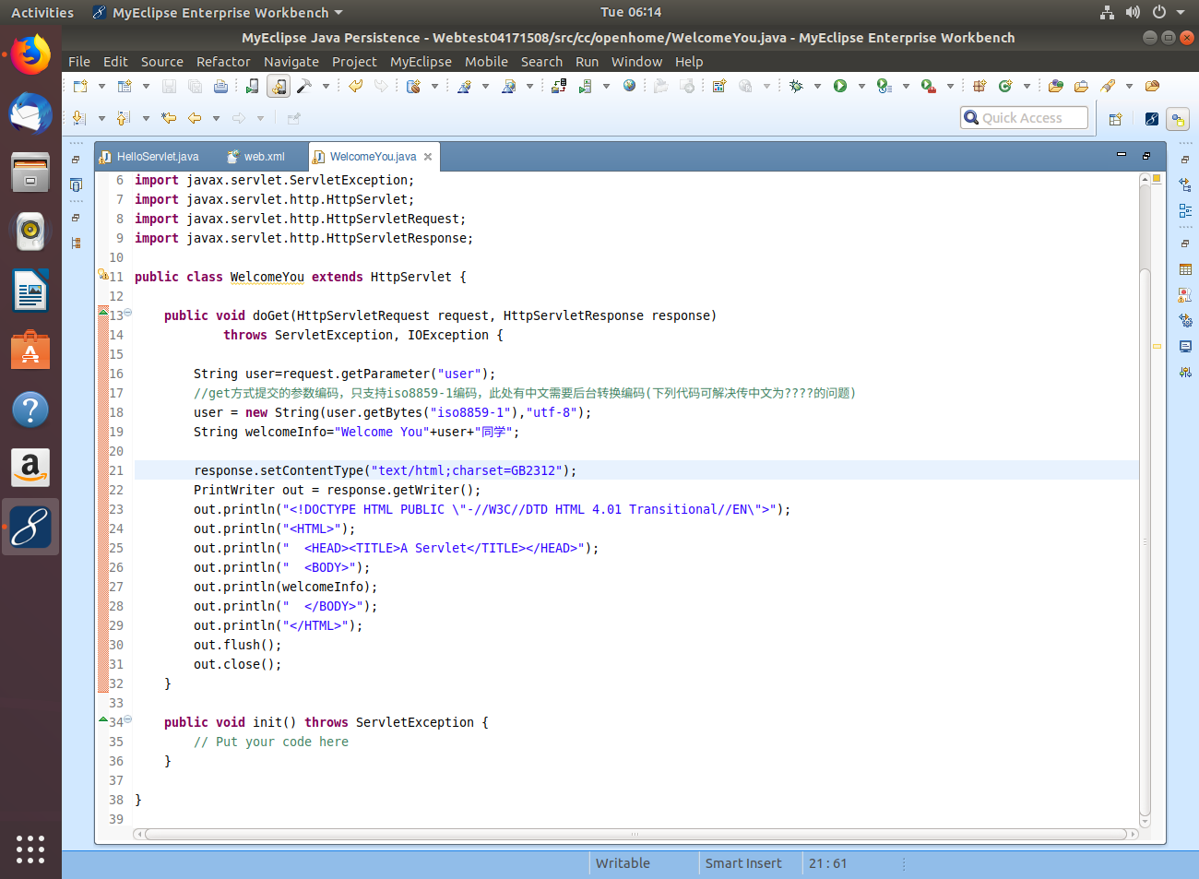

1. 意思是定义一个user的String变量并通过request.getParameter();进行对JSP取参数，把JSP文件中的数据读取出来

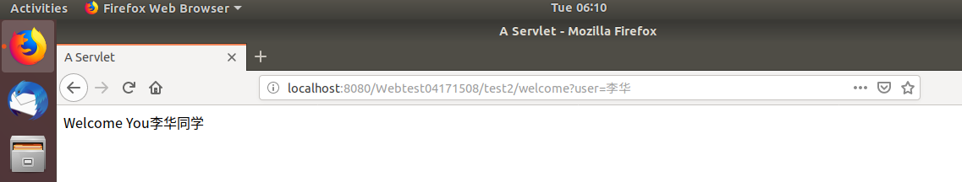

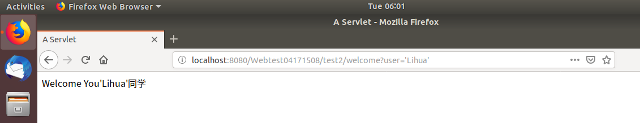

3.

1）用了<form><table><input type=”date”>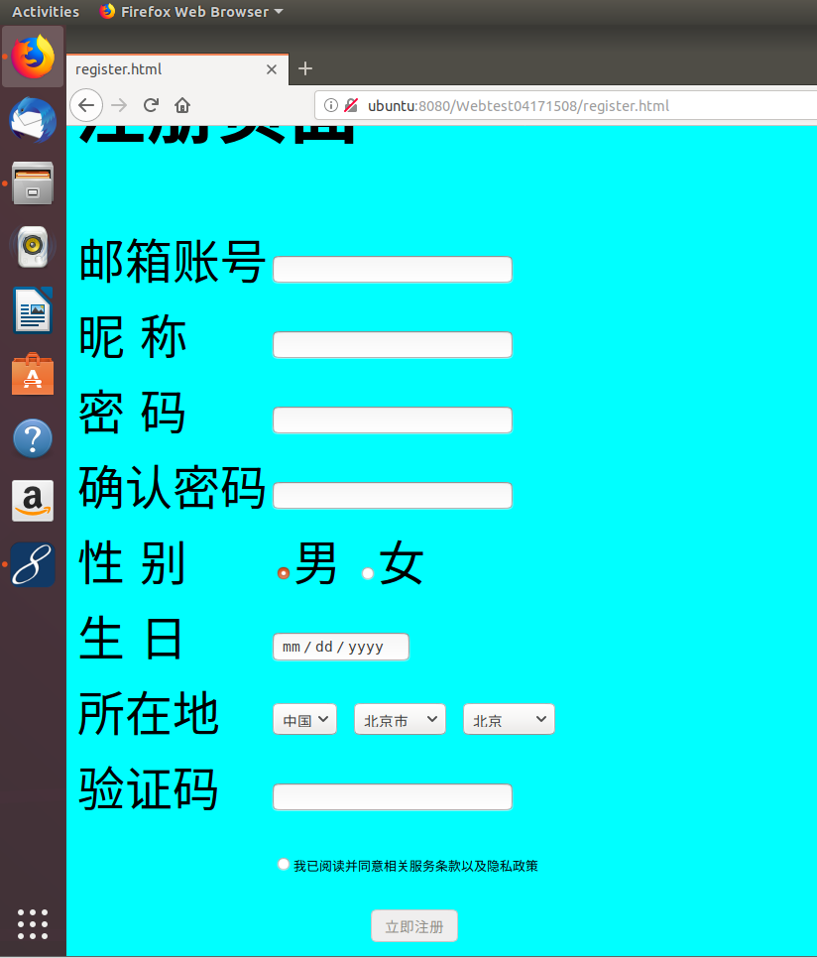

2）success.jsp

<%@ page language=*"java"* import=*"java.util.\*"* pageEncoding=*"UTF-8"*%>

<%

String path = request.getContextPath();

String basePath = request.getScheme()+"://"+request.getServerName()+":"+request.getServerPort()+path+"/";

%>

<!DOCTYPE HTML PUBLIC "-//W3C//DTD HTML 4.01 Transitional//EN">

<html>

<head>

<base href=*"*<%=basePath%>*"*>

<title>My JSP 'success.jsp' starting page</title>

<meta http-equiv=*"pragma"* content=*"no-cache"*>

<meta http-equiv=*"cache-control"* content=*"no-cache"*>

<meta http-equiv=*"expires"* content=*"0"*>

<meta http-equiv=*"keywords"* content=*"keyword1,keyword2,keyword3"*>

<meta http-equiv=*"description"* content=*"This is my page"*>

<!--

<link rel="stylesheet" type="text/css" href="styles.css">

-->

</head>

<body>

<% request.setCharacterEncoding("utf-8");

String name = request.getParameter("E");

// out.println("<P> 您的姓名:"+name+"</P>");

%>

<p>成功注册 ${param.E}

</body>

</html>

Fail.jsp

<%@ page language=*"java"* import=*"java.util.\*"* pageEncoding=*"UTF-8"*%>

<%

String path = request.getContextPath();

String basePath = request.getScheme()+"://"+request.getServerName()+":"+request.getServerPort()+path+"/";

%>

<!DOCTYPE HTML PUBLIC "-//W3C//DTD HTML 4.01 Transitional//EN">

<html>

<head>

<base href=*"*<%=basePath%>*"*>

<title>My JSP 'defaul.jsp' starting page</title>

<meta http-equiv=*"pragma"* content=*"no-cache"*>

<meta http-equiv=*"cache-control"* content=*"no-cache"*>

<meta http-equiv=*"expires"* content=*"0"*>

<meta http-equiv=*"keywords"* content=*"keyword1,keyword2,keyword3"*>

<meta http-equiv=*"description"* content=*"This is my page"*>

<!--

<link rel="stylesheet" type="text/css" href="styles.css">

-->

</head>

<body>

注册失败<br>

</body>

</html>

3)

